**Content to be used in the new website:**

* Headlines that we can use anywhere on the site:

“NATIONWIDE COVERAGE”

“UNRIVALLED WORLDWIDE EXPERIENCE AND EXPERTISE”

“CUTTING EDGE MICRO HD CAMERAS FOR UNOBTRUSIVE TRAFFIC COUNTS”

**HOME PAGE:**

(On this page I think we want to use some pictures of our camera equipment installed on site, to show how compact and unobtrusive it is, and I also think we want to use some good clear screenshots from the footage that we have collected at the various trial sites. We can maybe even have some short 20 second video clips embedded on there that the user can click on to play the short traffic video that we have filmed)

MHC Traffic India Pvt Ltd was formed to bring together a wealth of worldwide experience in the traffic data collection and analysis market, and to use this to serve both the public and private sectors in India by providing them with the most advanced and cutting-edge traffic data in the market.

**We are cutting-edge:**

We employ a combination of cutting edge, in-house developed camera equipment and report software, which allows us to undertake all types of traffic surveys, providing the HD footage to the client as verifiable back-up to the data provided.

**Why choose us:**

Our board of 6 directors possess a combined over 100 years of relevant experience and expertise in the traffic data collection and analysis fields, undertaking thousands of projects every year, across numerous countries and multiple continents. At all times our team strive to react and respond to our clients requirements, and will provide the most cost-effective tailored solution possible, with the shortest possible lead-in and turnaround times due to our large base of equipment and staff resources. This experience combined with our unrivalled data reports and insights, ensures our confidence in providing our clients with an industry leading service and product. Please feel free to get in touch with our team to discuss any requirements or questions you may have.

**NATIONWIDE COVERAGE** (separate tab header)**:**

(For this page, let’s do some kind of map of India, I’ve just used the below as an example. Then I think we want to include some text above the map something like the following)

From Kerala to Punjab, Odisha to Gujarat, we’ve got your traffic data collection needs covered. Just reach out to us with your requirements and we will look after everything from start to finish, from planning right through to data delivery.

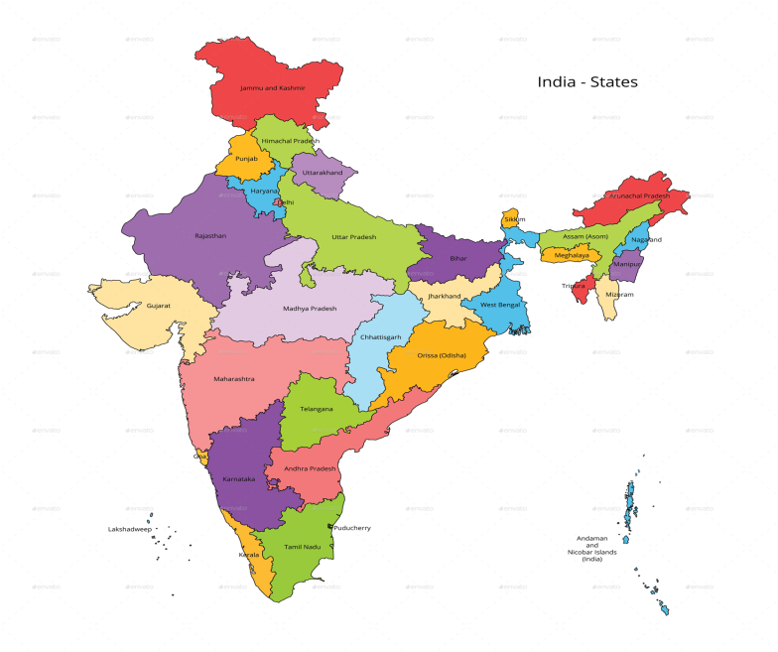

**OUR SERVICES** (separate tab header)**:**

(For this page we need some nice clear stock images for each type of traffic count, much like there is on the services page of the VTrac website. We need to use the following services and descriptions underneath each of the stock images)

* Classified turning movement counts: All vehicles for all movements are counted and classified and broken down into 15 minute time intervals.
* Classified vehicle link / Mid-Block counts: This is a two-way classified count of all vehicles, broken down into 15 minute time intervals.
* Pedestrian movement / Crossing counts: For this count type all pedestrian movements and crossings are collected in volume per direction of travel, and broken down into 15 minute intervals.
* Queue Length surveys: This survey measures the number of vehicles in a queue just before the traffic signals turn to green when the queue is at it’s longest, or simply the longest queue at a stop sign intersection. Queue lengths are recorded as the maximum number of vehicles per land in each 5 minute interval.
* Bicycle Counts: All cyclist movements and crossings are collected in volume per direction of travel, and broken down into 15 minute intervals.
* Journey Time Surveys: These surveys show you how long it takes to travel from one point to another, generally through a busy corridor of traffic. These surveys are undertaken by installing portable GPS units into each survey vehicle. These surveys also provide information relating to the delays encountered at each section of the route.
* Car Park / Parking surveys: On-street, kerbside, off-street, multi-storey car parks. These surveys assess the percentage occupancy and usage levels throughout various times of the day and week.
* Illegal Movement surveys: These surveys provide a classified breakdown by time intervals, showing all vehicles that undertake the observed illegal movement.
* Rail / Bus Passenger Boarding / Alighting surveys: These surveys provide data relating to the volume of users who board and alight each method of public transport, showing usage levels for various times of the day and week.

**FOOTAGE ANALYSIS & REPORTS** (separate tab header)**:**

(For this page I think we want to have some nice pictures taken from within your office showing the staff working on analyzing the footage. I also think we want to show some pictures of our report format on here as well – we can get some images to you for this)

One of our core strengths at MHC Traffic India Pvt Ltd is our experience in undertaking all types of traffic data analysis from footage, undertaken either by ourselves or our clients. We have had an established presence and base in the Indian market for over 15 years now, with an experienced team of over 75 working at our Head Office in Bangalore. The footage can be analyzed for all types of surveys and classifications, and all data will be provided in our industry leading report format, which can always be tailored to suit any individual requirements the client may have.

**CONTACT US** (separate tab header)**:**

(I think for this page we want a simple contact form if the client wants to get in touch that way. I also think we want a map of where the office is, alongside all contact details and address etc)

**Get in touch:** Please feel free to reach out and contact us using any of the methods or contact form below. We would be delighted to hear from you, and will be more than happy to assist you in any way possible.

**ABOUT US** (separate tab header)**:**

(I think for this page we want to use some of the text from the Home Page and then have individual pictures of all 6 directors, with their title and experience underneath – for example under the picture of Neil it could just say “Neil McMillan (Director) – 25 years of traffic data collection experience worldwide”)

Our board of 6 directors possess a combined over 100 years of relevant experience and expertise in the traffic data collection and analysis fields, undertaking thousands of projects every year, across numerous countries and multiple continents.